**Homework 4 – Times Series, and Forecasting**

**Yubing Li 00808366**

**1. Chocolate:**

**(a) Time plot**

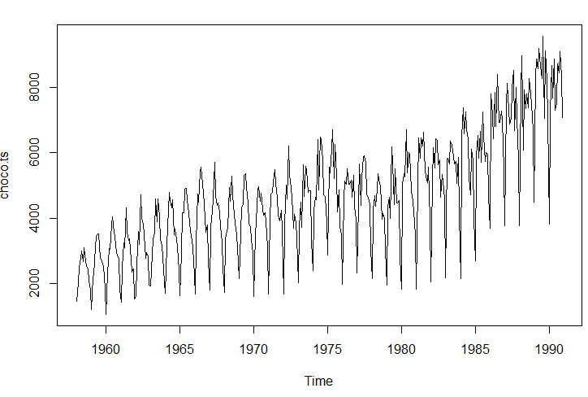

In general, the overall trend of chocolate consumed is linearly increasing, with slightly increasing variability. The high numbers occur in summer. The plot shows that there’s no obvious fatality to the number of the chocolate consumed.

**Aggregated series**

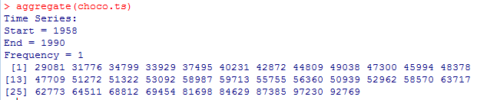

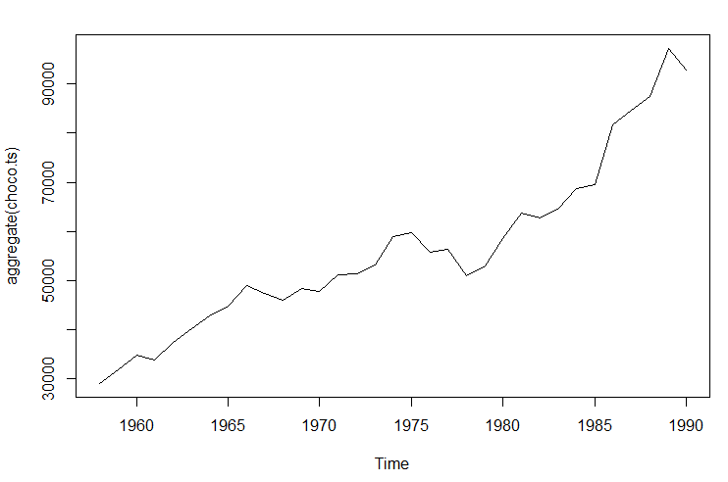

In general, the aggregation plot shows that across the years, the aggregated consumption of chocolate was increasing, while in some years (e.g. 1977), it gently decreased.

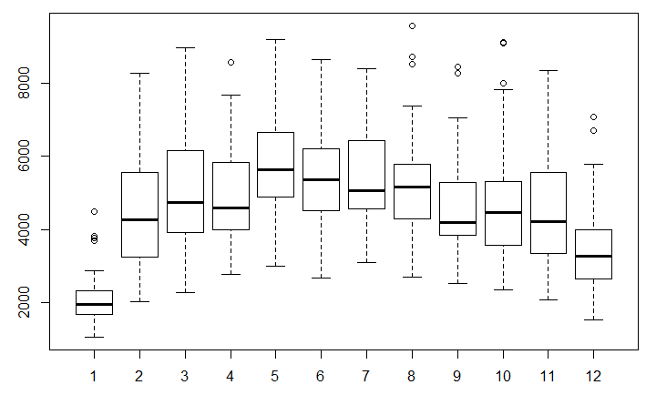**Boxplot**

In general, the boxplot shows that in winter seasons (Dec, Jan), the average of chocolate consumed is the least among all. In the summer seasons (May, June, July), the average of chocolate consumed is the highest.

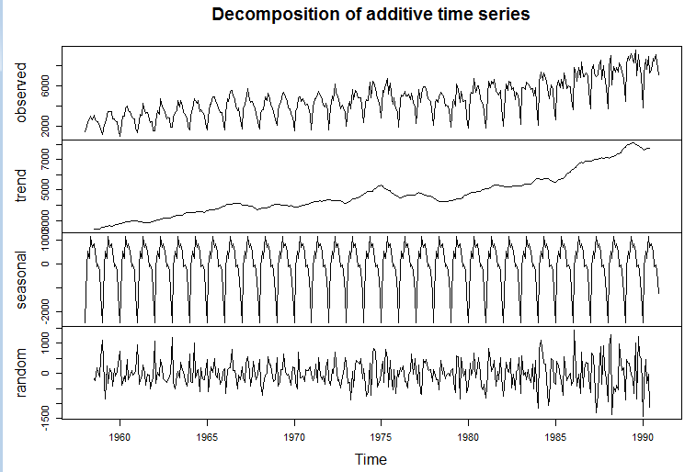**(b) Decomposition:**

Raw data

Moving average

Seasonal piece plotting

Random residuals

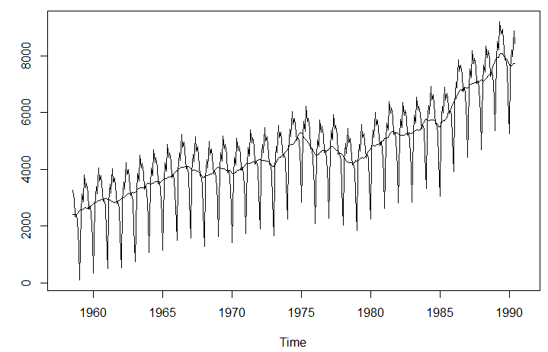

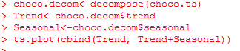**Decomposed series:**

**(For multiplicative type)**

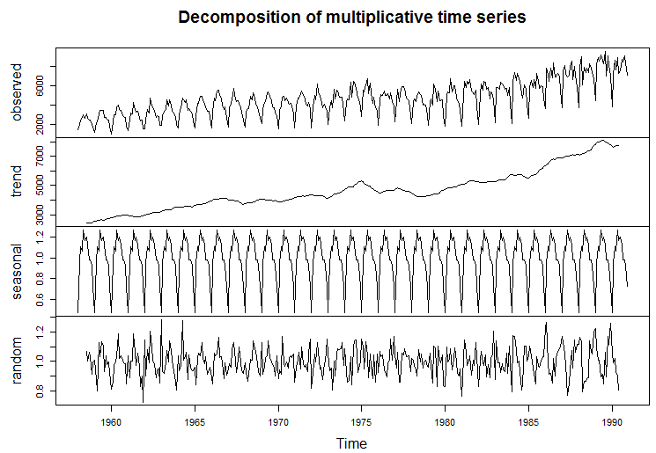

Raw data

Moving average

Seasonal piece plotting

Random residuals

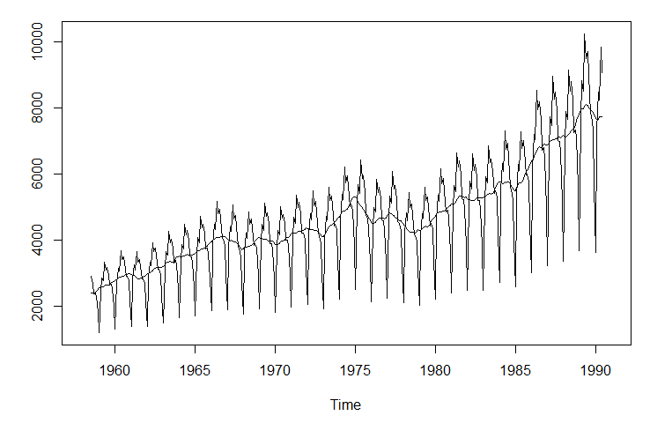

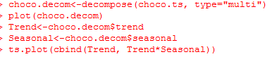**Decomposed series:**

**2. Volume:**

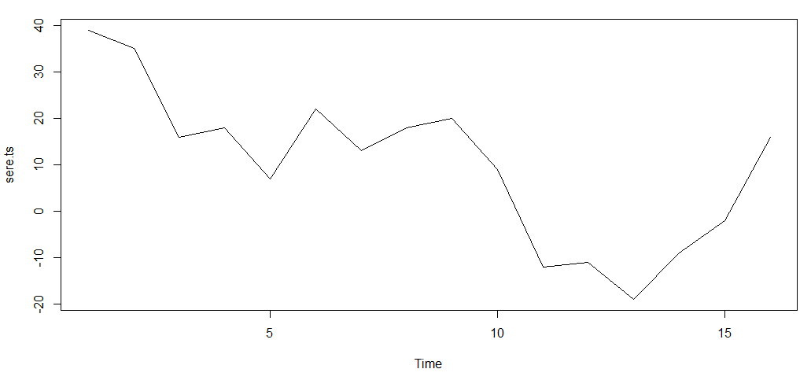**(a) Time plots**

Serendipity:

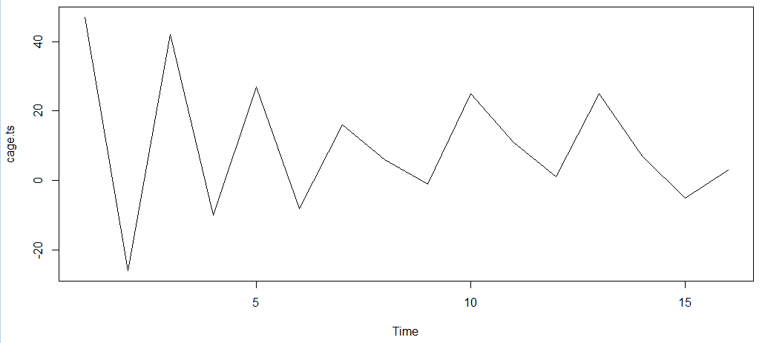

Cagey:

**(b) Lag 1 scatter plot:**

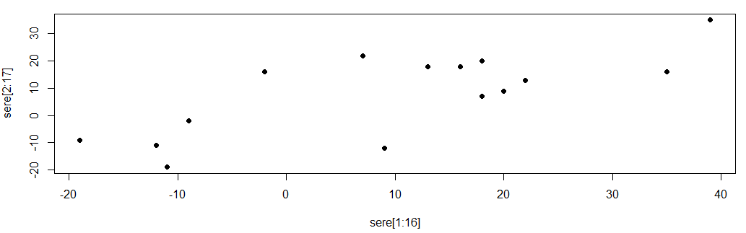

Serendipity:

r = 0.7502

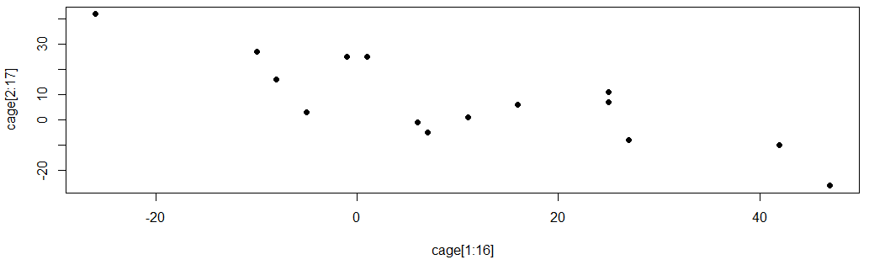

Cagey:

r = -0.8252

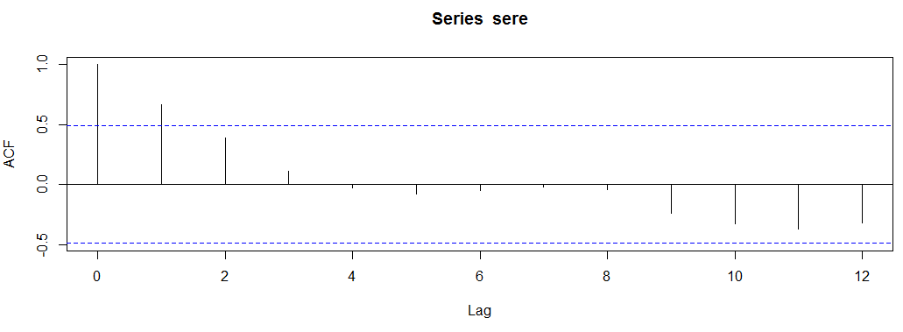**(c) acf:**

Serendipity:

For points that are close to each other (in between 2 points), there’s a moderately strong positive linear correlation between points.

For points that are far apart (after 9 points) there’s a moderately strong, negative linear correlation between points.

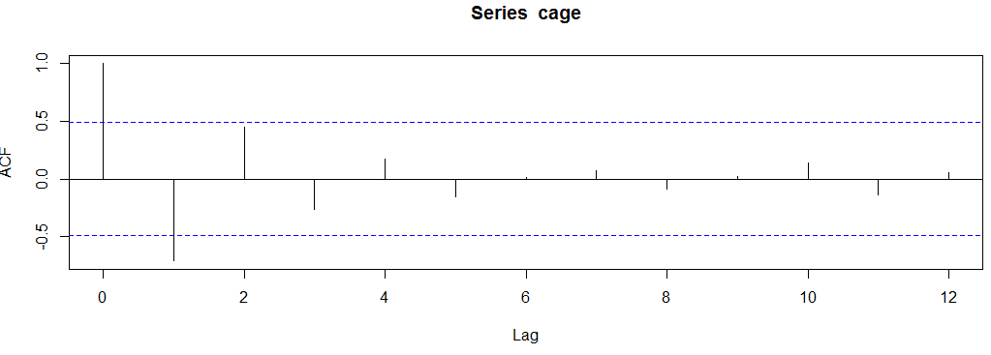

Cagey:

For points that are far apart (after 2 points), they have less correlation between each other.

What’s more, for points Xt and Xt+k:

when k is odd, the correlation is negative; when k is even, the correlation is positive.



**3. Global temperature:**

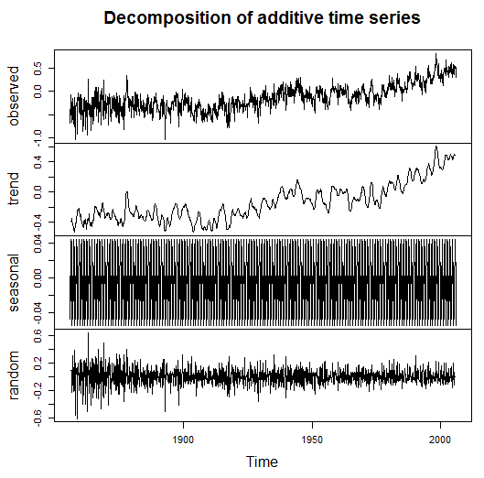

Raw data

Components trend

Seasonal effects

Residuals

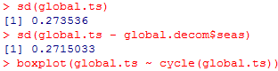

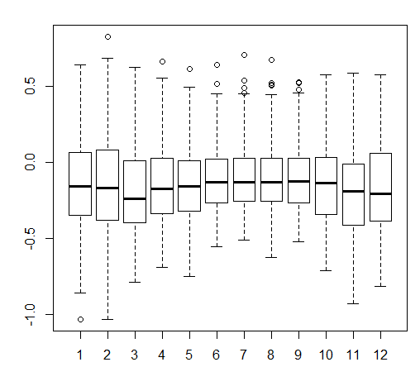

Since the data is for global temperature, we would not expect any observation of substantial seasonal variation.

From the boxplot, we can see there’s little difference among each month, and confirm our expectation.

**Plot with seasonal effect:**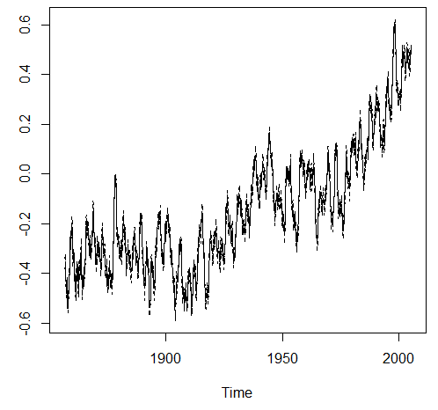

The sds are 0.2735 and 0.2715.

Again, there’s little difference between two standard deviations, which proves that there’s no seasonal effect.

**(b) Correlogram:**

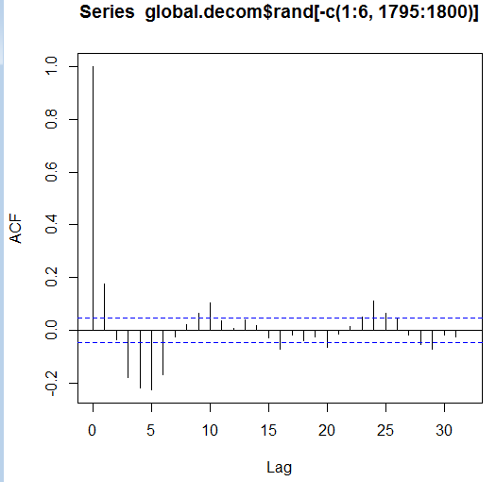

We can see that there’s strong, positive correlation for points that are close to each other (lag 1).

And there’s periodic correlation for every five years.

(E.g.) for lag 5, the correlation is negative;

for lag 10, the correlation is positive.

In general, the global temperature between every two month are moderately correlated. What’s more, there’s cyclical trends from seasonal period.

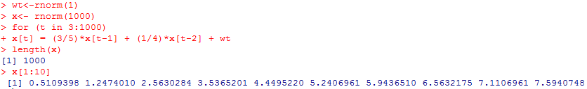**7. AR(2):**

**(a)**

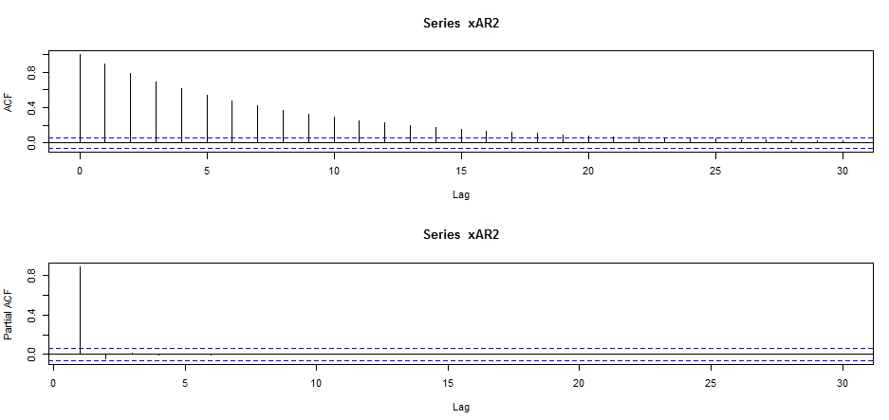

**(b)**